Name: Saiba Pathan
B.Voc - Software Development
Roll_no: 09
Div: C

Lab – 10
Title: Application Load Balancer Demo with Path-Based Routing
Objective
This lab demonstrates how to set up an Application Load Balancer (ALB) in AWS to route HTTP traffic to three different EC2 instances representing microservices in an e-commerce application. Traffic is routed based on the request path in the HTTP header.

Architecture Overview
EC2 Instance 1: Serves the main e-commerce homepage (/)
EC2 Instance 2: Serves the products page (/products)
EC2 Instance 3: Serves the billing page (/billing)
Application Load Balancer (ALB): Routes traffic to each instance based on HTTP path rules.

Prerequisites
AWS Free Tier account
AWS CLI configured or CloudShell access
Existing VPC and subnets
IAM permissions to create EC2, ALB, Target Groups, and Security Groups

Lab Steps
Step 1: Launch Three EC2 Instances
Launch three Amazon Linux 2 t2.micro EC2 instances in the same VPC and subnet. Ensure they are in the same Availability Zone and have a security group that allows HTTP (port 80) & SSH (port 22) access.
Use user-data scripts to configure each instance to serve a different HTML page:

EC2 1 (Homepage):
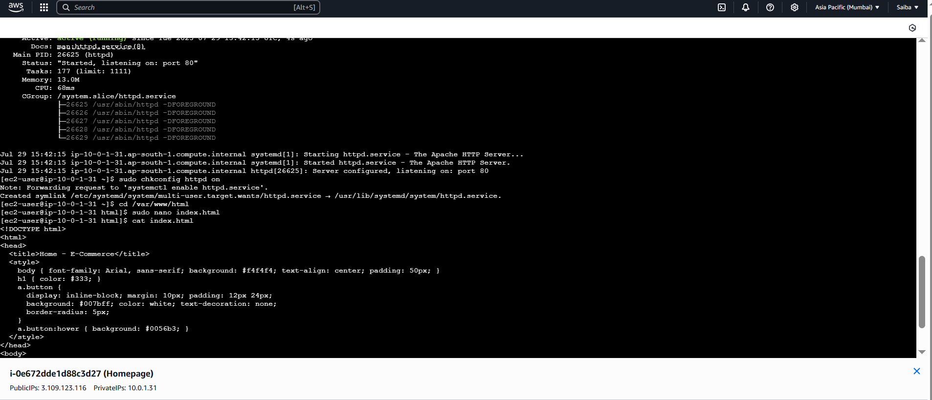

#!/bin/bash
echo "<h1>Welcome to E-Commerce Site</h1>" >
/var/www/html/index.html yum install -y httpd systemctl start httpd systemctl enable httpd EC2 2 (Products):
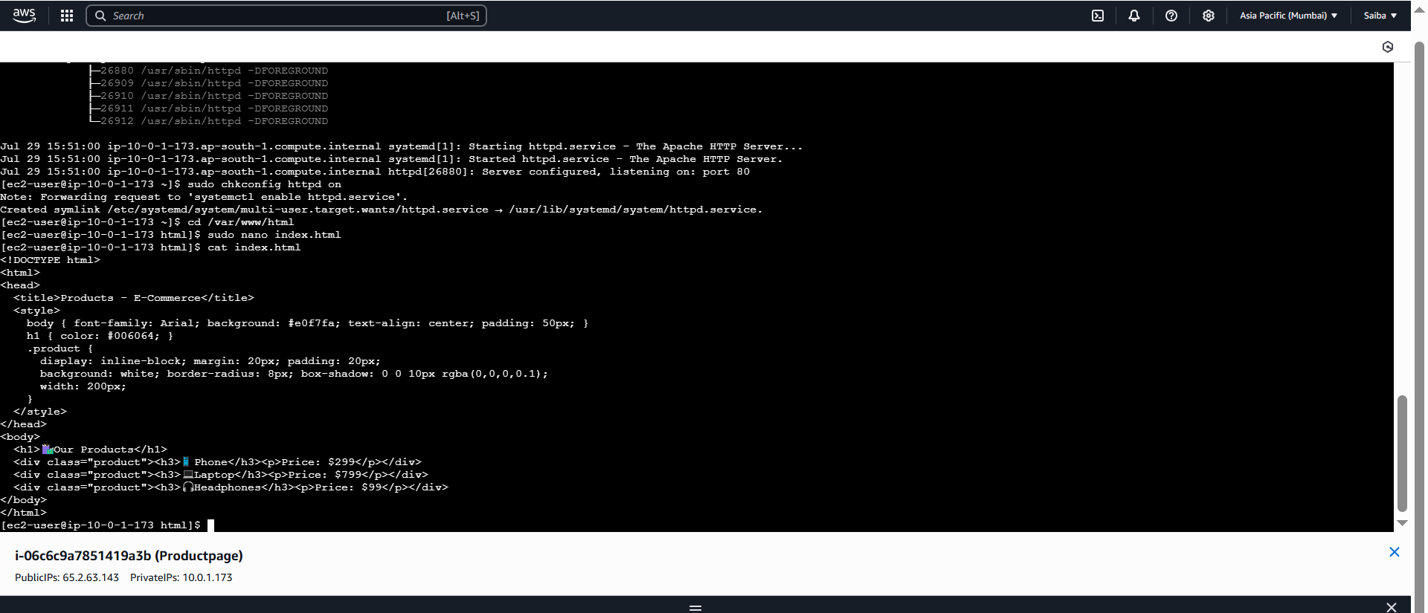

#!/bin/bash
echo "<h1>Products Page</h1>" > /var/www/html/index.html yum install -y httpd systemctl start httpd systemctl enable httpd EC2 3 (Billing):

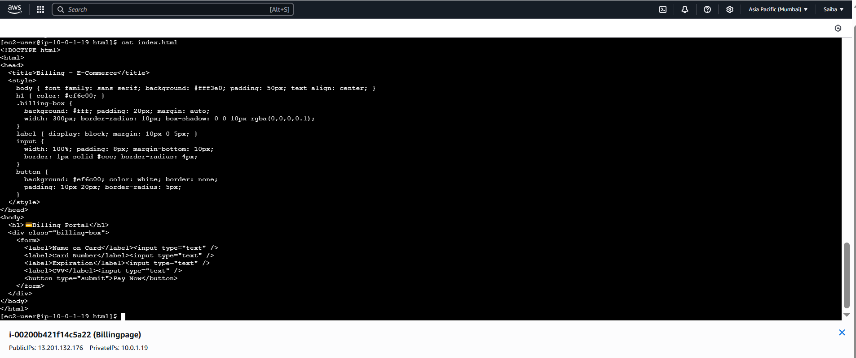

#!/bin/bash
echo "<h1>Billing Page</h1>" > /var/www/html/index.html yum install -y httpd systemctl start httpd systemctl enable httpd

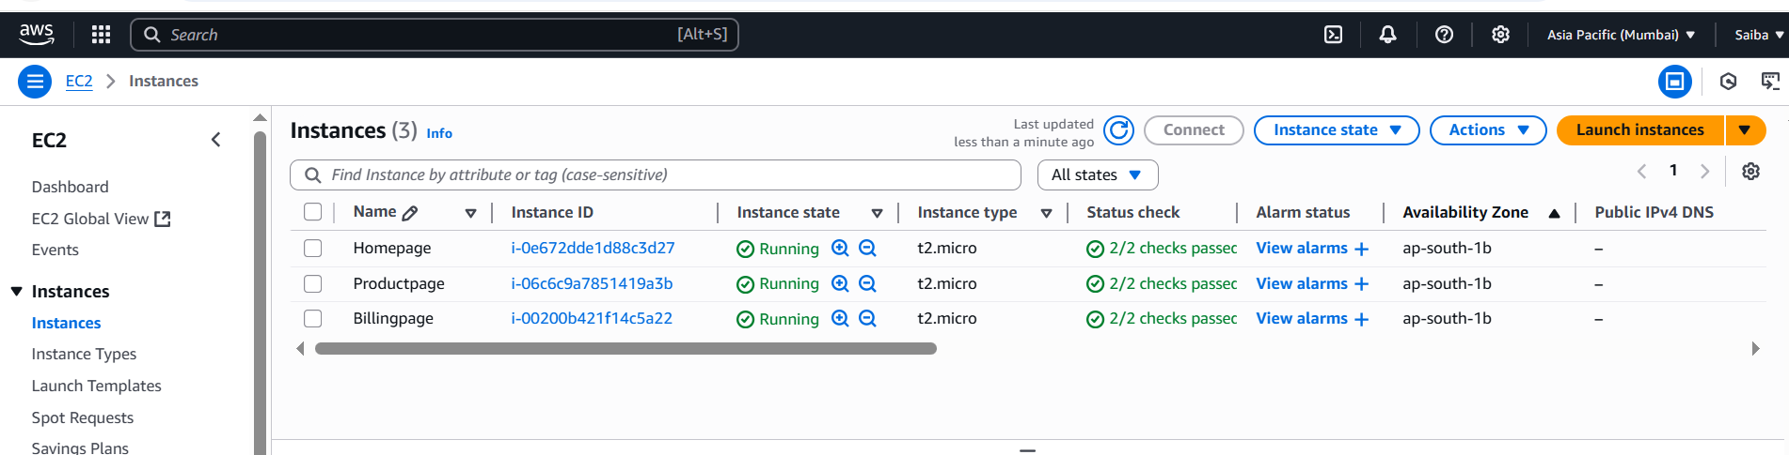

Step 2: Create Target Groups
Create three target groups in the same VPC:
ecommerce-home
ecommerce-products- ecommerce-billing
Register each EC2 instance with its corresponding target group.

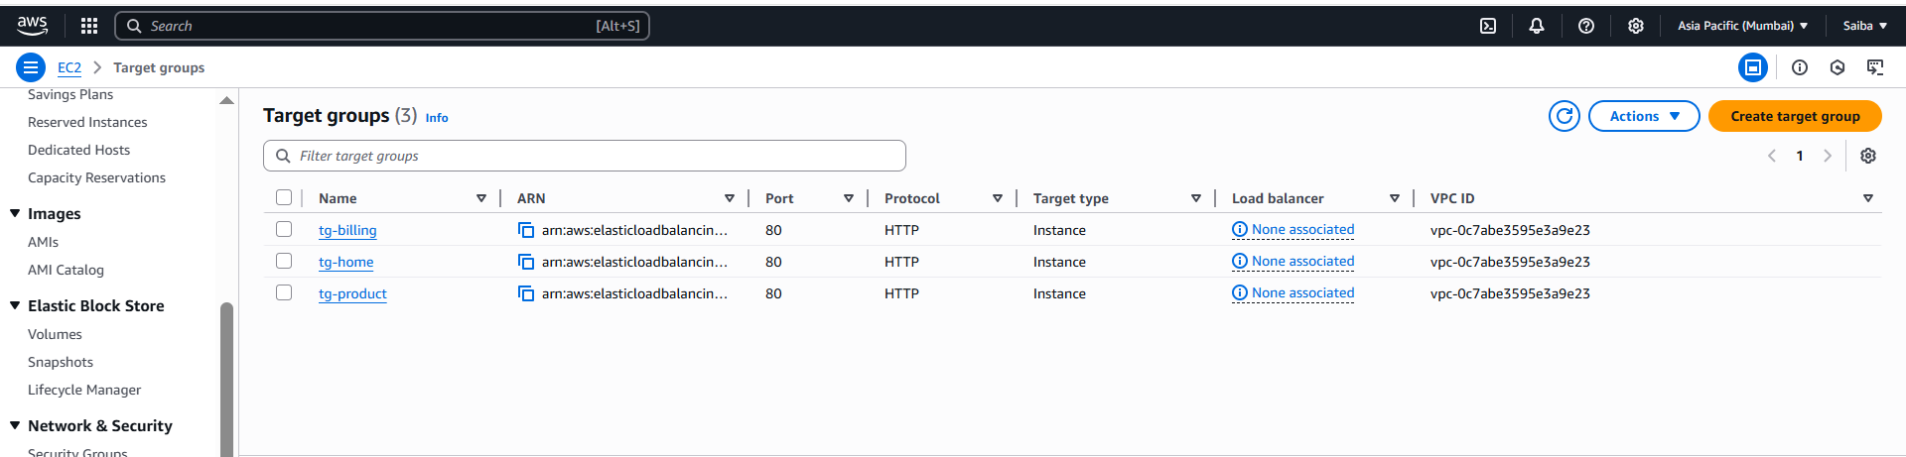
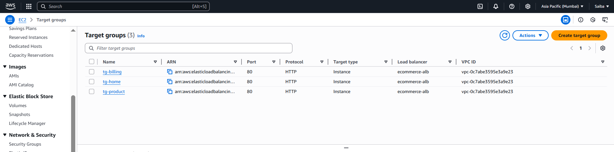
Step 3: Create the Application Load Balancer
Create an ALB in the same VPC and Availability Zone. Attach at least two subnets and the security group that allows HTTP access (port 80).

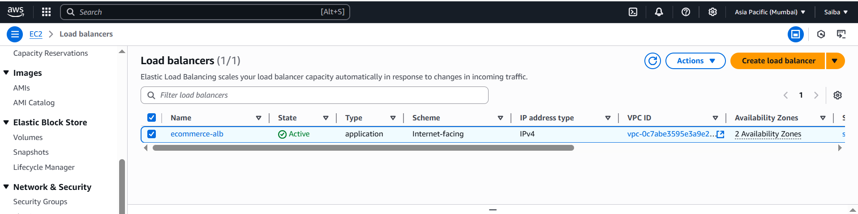

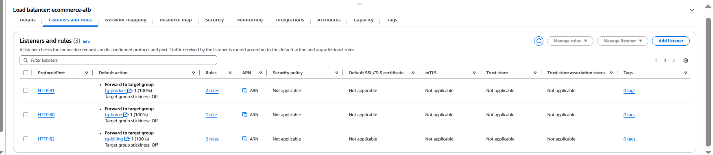

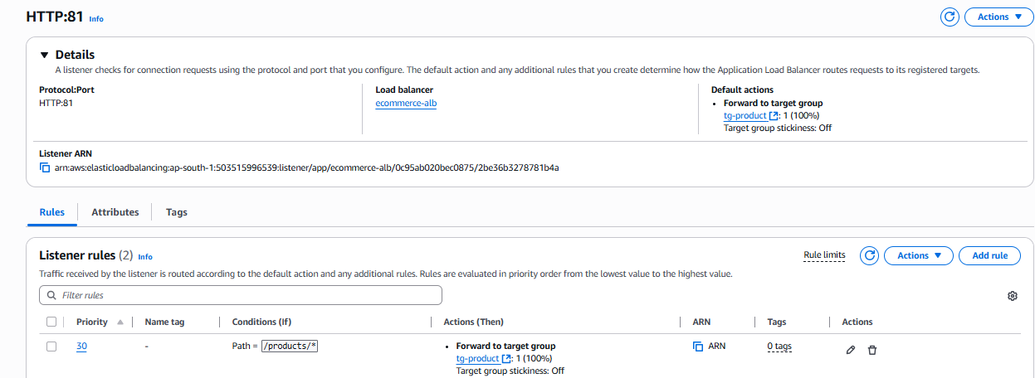

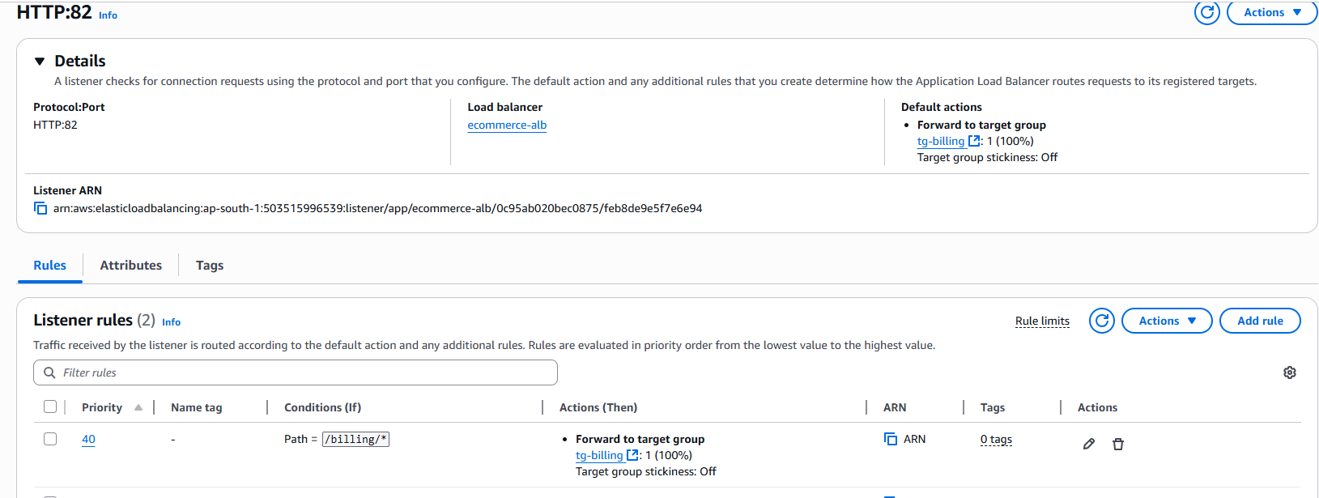

Step 4: Add Listener Rules
Configure the HTTP (port 80) listener with rules:
Rule 1: If path is /, forward to target group ecommerce-home
Rule 2: If path is /products, forward to target group ecommerce-products
Rule 3: If path is /billing, forward to target group ecommerce-billing
Step 5: Test the Setup
Use a browser or curl to test:
http://<ALB-DNS>/ → E-Commerce Homepage
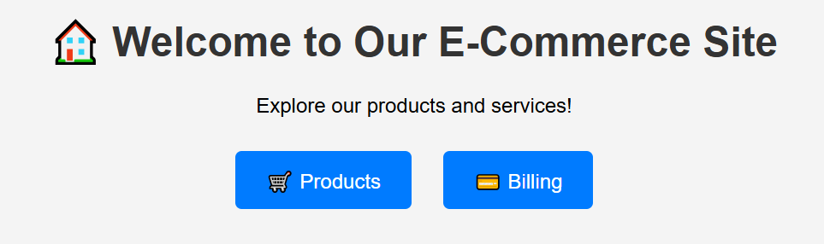
http:// e-commerceALB-01-1867921648.ap-south-1.elb.amazonaws.com/products → Products Page

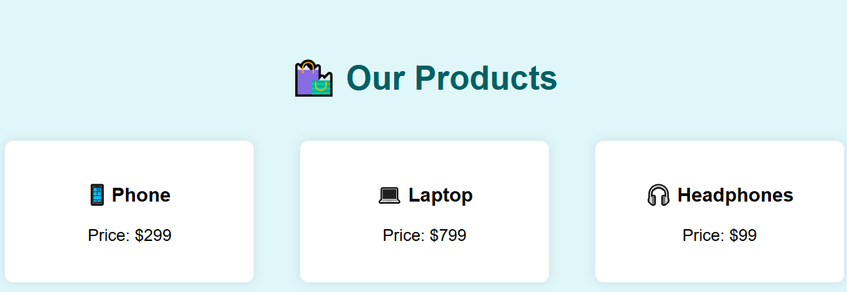

http://<ALB-DNS>/billing → Billing Page

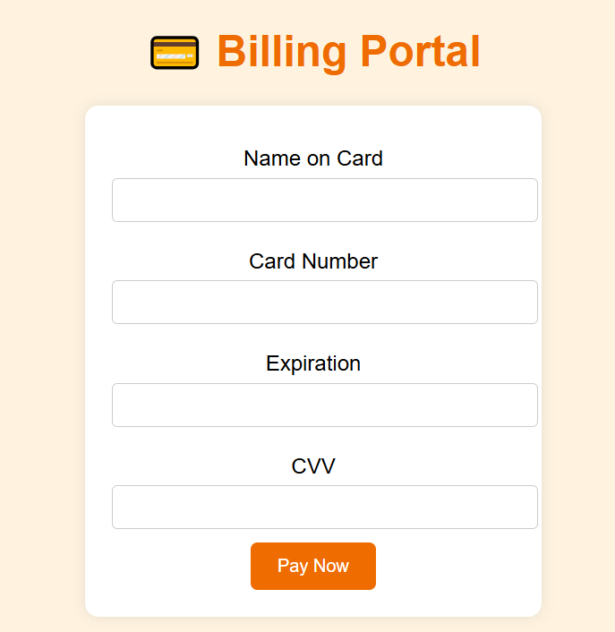

Cleanup (Optional)
Terminate the EC2 instances, delete the ALB, target groups, and security groups created for this lab.

Summary
In this lab, you learned how to deploy a basic microservices architecture using EC2 instances behind an Application Load Balancer. You implemented path-based routing using listener rules to serve different content from each instance.
Instructor Remarks
